
IRFANVIEW – Graphics File Viewer/editor for Windows systems
FREEWARE
From Irfan Skiljan - http://www.irfanview.com/ by GLENN ROSSITER

Windows Software used for quick-easy Full-screen Viewing of Images (and Video) formats on screen at their Native resolution using the allocated system Monitor color profile, unimpeded by other items such as menu’s toolbars etc. This software also allows for many other functions such as simple Editing and painting, File Thumbnailer viewing, File Batching functions, Screen captures and dumps, Standard 8bf Plugins etc.
Easily configurable Options-Properties and Settings with a separate Executable file for many Industry standard Plugins and Codecs. For now ….. I will describe Installation, Set Options and easy Viewer Usage.

INSTALLATION and USE

STEP1. Download from the IrfanView site (or Filehippo.com site) the 2 executable SETUP files for the latest Version of the software. Updates can always be installed directly over any previous versions.
These files are usually called [ irfanviewXXX_setup.exe ] and [ irfanview_plugins_XXX_setup.exe]

STEP 2. Right-click to RUN the master SETUP executable File.
Locate the installation where you wish …. Default is C:\program files\Irfanview. Accept default check boxes generally, Install for All Users, Select [Images Only] for file associations, BUT UNCHECK the 3 file formats of CRW/CR2 + PSD + RAW Image Data. These you want to double-click into Photoshop directly !!

(Ignore the W7 warning dialogue box that states program did not install properly …. if it pops up)

STEP 3. Firstly close any webpage window that comes up and close the Irfanview Program if it automatically starts. Right-click to RUN the PLUG-Ins executable File.
This will automatically install the necessary file format Plugins into the IrfanView installation folder you have just completed and announce a Success dialogue box ……. Close this and you are ready to set Preferences.
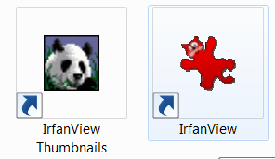
STEP 4. You should now have 2 Icons on the Desktop …. one Red-Squashed Cat Icon for the main program and one for the Irfanview Thumbnailer ……………………

These can be placed where you wish BUT …… USAGE of the IrfanView software is MOST EASILY accomplished from within the Windows Explorer applet (or My computer applet) of the Operating System. This is set in Properties/Settings as below as a result of File associations done in Step 2 above.

STEP 5. Click the Red Squashed Cat Icon to Restart the Main Irfanview Program window. Maximise this window

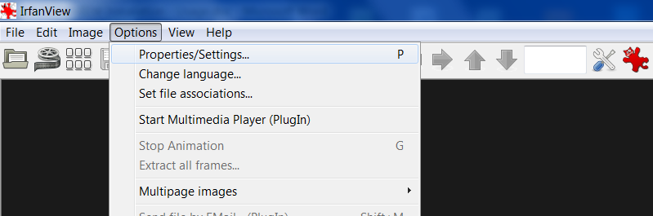
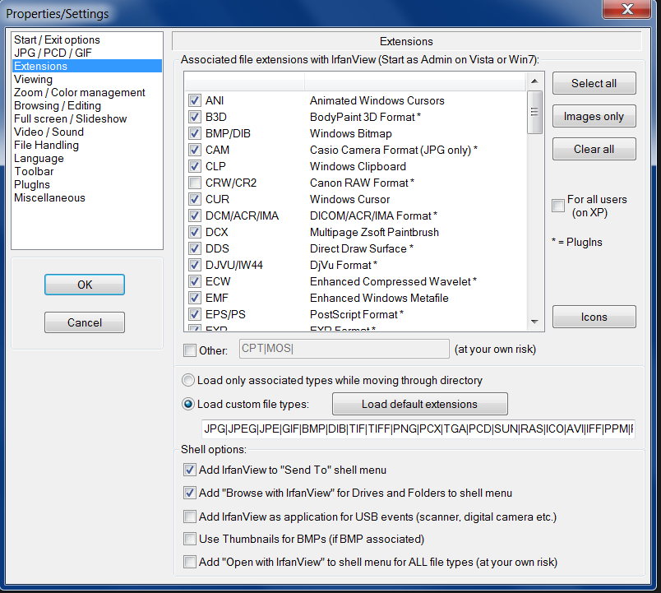
Click Menu Bar - Options - Properties/Settings

MOST of the Properties/Settings dialogue
Boxes are left as defaults EXCEPT as shown

1. Click Extensions ………………………

NOTE the Shell Options ticked here …….
The Add “Browse with Irfanview” checkbox allows the Thumbnailer program to be called from within normal Windows Explorer (or My Computer)
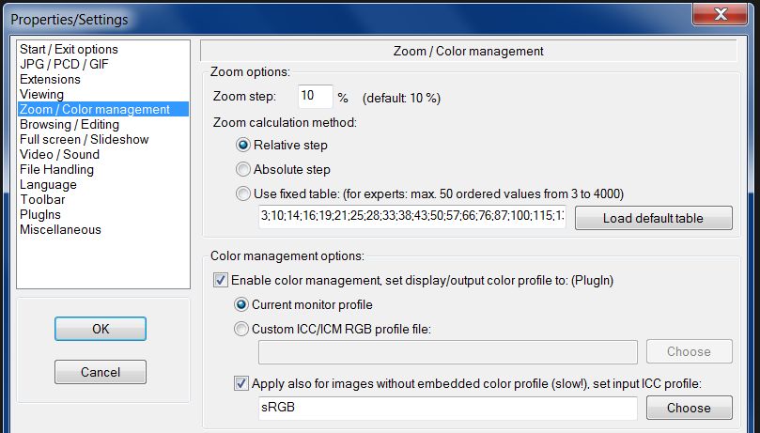
- ZOOM /Color management …..

NOTE the enabled “Current Color management” and monitor profile
radio button clicked ……….

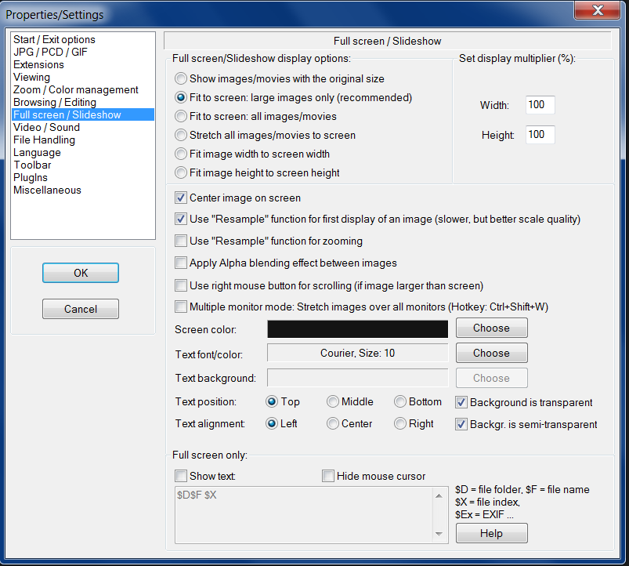
- FULLSCREEN/Slideshow …….

NOTE the settings here are generally defaults

UNCHECK the SHOW text button to stop
The File name being displayed on screen

ALSO Note if you wish, you can set the full Screen background Color using Choose ..
The Main program window background color can also be set in the “Viewing” TAB

THIS COMPLETES the PROGRAM Properties Setup procedures ……. Close IrfanView NOW !!
………………………………………………………………………………………………………………..
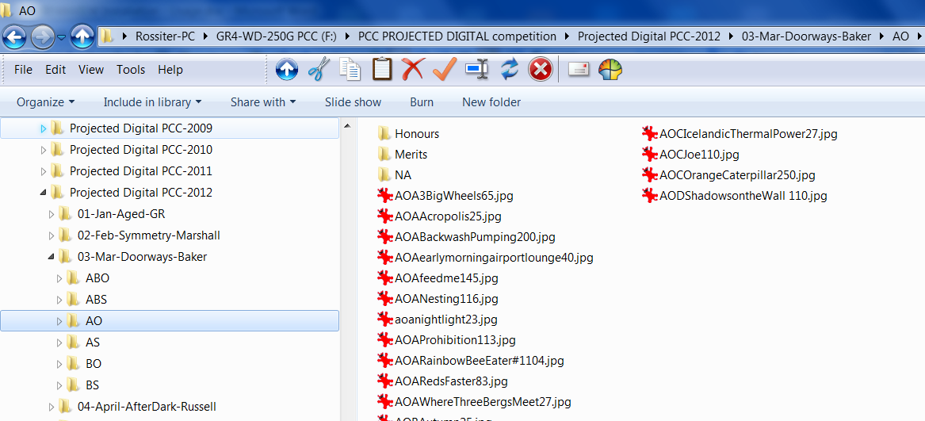
HOW to use IRFANVIEW
in normal computer operation

USE WINDOWS EXPLORER
(My Computer) to NAVIGATE to a Hard-drive or DVD FOLDER containing Graphics Images …….

Note the Squashed cat association
Icon beside the Filenames ….

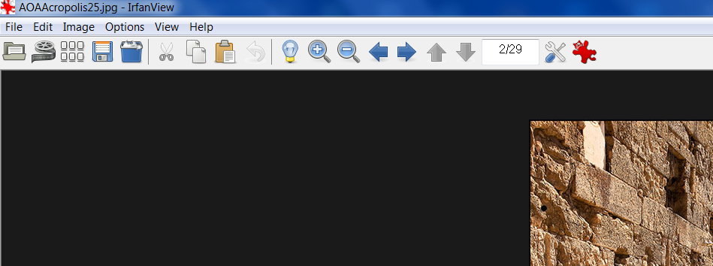
DOUBLE CLICK the first *.jpg file in the file listing and the Image will come up automatically in the Irfanview Main Menu Bar Window. Maximise this window

HIT the ENTER Key
This causes the Image to go to Full-Screen

Use the forward – backward ARROW Keys To change Images in sequence ….
HIT the ESC Key … to come back to the Menued IrfanView Screen ( forward-backwards arrows still work )
HIT the ESC Key …… again to completely exit the Program and be back in the Windows Explorer.

The program can also be started with the Thumbnailer …… but the above procedure is best for ease of use.

